Assignment 4

Writing Introduction, Results & Conclusion
File name & format | RMT_A4_Team_KozhabekRamazan_ShaikenovDanial.docx

Group | SE-2426
Team | KozhabekRamazan_ShaikenovDanial
Research Question | How do loading data in separate batches and continuously adding new data affect web application performance?
Link to public cloud folder | https://github.com/Ramazan-droid/RMTdata
Word, Figures, Tables count  for Results & Discussion only | 1691 words; 7 figures/graphs; 12 tables.  Excludes table text, captions, file paths, folder links and appendices.

Segment 1. Article Structure
Table 1. Structure of the research manuscript
Chapter | Sections and subsections
Introduction | Background and problem; Literature Review and Research Gap: technical evidence, navigation evidence, selection criteria and remaining gap; RQ, aim, hypothesis and all A1 objectives.
Methodology | Design and Evidence Sources; Variables and Measurement Rules (concept table, units, paired comparison); Procedure and Environment; Provenance and Data Handling.
Results and Discussion | Task 1 Inventory; Task 2 Data preparation; Task 3 Results by objective; Task 4 Expected versus observed; Task 5 Analysis pipeline and interpretation steps.
Results and Discussion continued | Task 6 Block D: run-level outcomes, retained content, live heap, main-thread work, batch-ready delay, initial paint, requirements and failure cases; Task 7 Additional interpretation; Task 8 Literature comparison; Task 9 Validity and limitations.
Conclusion | Answer and contribution; expectations and next study; submission checklist.
References | Alphabetical Harvard reference list; publication-title links.
Appendices | A All supplementary runs; B Other unchanged A3 expectations; C Observed interface states; D Evidence index; E Literature search and selection audit.
The paper follows the same question from the introduction to the conclusion. The local experiment provides the direct comparison, while the older public-site measurements provide context and are analysed separately.

Segment 2. Title, Abstract and Keywords

Title
Table 2. Final title
Final Title | Memory Growth and Loading Delay in Paginated and Infinite Scroll Web Interfaces | Why?  Names the measured outcomes, the loading approaches and the web-interface context. It does not assume that either approach wins on every metric.
Memory growth and loading delay are the two outcomes most directly related to the original question. The title leaves room for a memory difference without a corresponding improvement in loading time.

Abstract
Abstract | This study compares pagination and infinite scrolling in the same React and Node.js application. Forty supplementary browser trials formed twenty pairs, each delivering 500 records in batches of twelve. Fresh sessions, alternating condition order and matched artificial-delay seeds were used. At the final checkpoint, mean post-GC JavaScript heap was 2.315 MiB for pagination and 4.418 MiB for infinite scroll. The interfaces retained eight and 500 cards respectively. Mean batch-ready latency was 164.3 and 167.8 ms. The results distinguish retained-content cost from loading delay. The original public-site archive was also checked, but its field measurements cannot isolate loading strategy. Initial paint and prolonged browsing are reported separately. The findings apply to this implementation and workload, and do not establish a universal ranking or confirm all expectations from Assignment 3. | Word count  133

Keywords
Keywords | pagination; infinite scrolling; JavaScript heap; DOM growth; loading latency; technical benchmark

Introduction

Background and Problem
Developers of catalogues, search results and content feeds have to decide what happens to an earlier batch when another batch arrives. Pagination replaces it, whereas infinite scrolling keeps it on the page. The choice matters during long browsing sessions on desktop and mobile devices because keeping more content may use additional resources. Users care about waiting time and responsiveness, while developers need evidence that separates these outcomes from the size and content of the application.

Literature Review and Research Gap
Technical evidence
van Riet, Malavolta and Ghaleb (2023) investigate industrial web-performance interventions, while Gavrila et al. (2022) measure database-pagination query cost. These outcomes concern different system layers. Neither study directly estimates the browser-memory effect of retaining previously viewed cards.
Alnuhait et al. (2024) inform performance-test design. Demir et al. (2022; 2023) inform documentation of measurement conditions. Lipiński and Pańczyk (2023) compare equivalent application cases and report metric-dependent results. These sources support controlled measurement, rather than a universal ranking of navigation techniques.
Navigation evidence and disagreement
Salmerón et al. (2024) did not detect navigation moderation in their handheld-device synthesis. Clinton-Lisell and Litzinger (2026) found different paper/screen patterns in scrolling and non-scrolling subsets. This is a documented empirical discrepancy, although the datasets and analysis methods differ. Task 8 states the device-specific limits.
Joshi, Casiez and Vogel (2025) found no significant smartphone navigation differences in comprehension, duration or workload. Krenca, Taylor and Deacon (2024) likewise found no significant comprehension disadvantage for scrolling alone relative to clicking. Neither null finding proves equivalence, and neither measures JavaScript heap.
Haverkamp et al. (2023) recommend considering paging, but their integrated-comprehension effect did not meet the conventional .05 significance threshold. This advice is therefore discussed separately from statistically supported effects. Opposite recommendations are not automatically contradictory measurements.
Selection rules and remaining gap
The targeted update on 29 October 2026 retained eleven journal/conference publications from 2022–2026 with accessible full methods and results. Publisher full texts and author manuscripts were accepted; access versions are identified. Abstract-only records, unverified preprints and insufficiently documented benchmark claims were excluded from the evidence base. Official metric documentation is listed separately.
Appendix E records the search families, inclusion rules and decisions for every original A2 candidate, including the eight retained in its matrix. Excluded candidates remain visible as screening history; their unverified results are not reused as evidence.
The remaining gap is a comparison of replacing and retaining equal batches in the same application as the amount viewed increases. Our technical benchmark addresses that gap. Reading studies explain why a technical resource cost cannot establish user preference or comprehension; unrelated public-site measurements cannot isolate the navigation rule.

RQ Aim Hypothesis and Objectives
Research Question: How do loading data in separate batches and continuously adding new data affect web application performance?
Aim: To determine how loading data in separate batches and continuously adding new data affect web application performance.
Hypothesis: Loading data in separate batches will maintain better web application performance than continuously adding new data as the amount of loaded data increases.
1. Develop two data loading approaches: loading data in separate batches and continuously adding new data.
2. Measure loading time, memory usage, rendering time, and the number of page elements for both approaches.
3. Conduct performance tests as the amount of loaded data increases.
4. Compare the performance results of the two data loading approaches.
5. Determine how each data loading approach affects web application performance.
The RQ and objectives retain their original wording. Here, performance is interpreted through separately reported loading, memory, DOM and browser-task measurements. Objective 5 is the final synthesis rather than an additional measurement.

Methodology

Design and Evidence Sources
The study uses a quantitative technical benchmark and reports Block D. The original team archive contains Prometheus query snapshots and public-site values copied from PageSpeed Insights. A supplementary experiment was run on 29 October 2026 to address the unequal workloads and missing browser measurements in that archive. The new logs are kept separately; they are not presented as measurements collected for Assignment 3.
The application uses an in-memory archive of 500 mission records. Both React components request twelve records at a time through the same API. Pagination replaces the displayed cards, while infinite scroll appends the next batch. The source code does not support the A3 description of an infinite-scroll batch size of twenty. The application is the measurement instrument; the ten public websites are a separate observational case set.
C1 Backend source | C2 Shared frontend fetch function | C5 Pagination component | C6 Infinite scroll component

Variables and Measurement Rules
Table 3. Concept table and operational definitions
Variable or concept | Indicator and level | Meaning
Loading approach | Nominal: pagination or infinite. | The only intended interface difference is replacing versus retaining earlier batches.
Content depth | Ratio: 12, 120, 252 and 500 delivered records. | Total records received so far; distinguished from cards currently retained.
Retained content | Ratio: card count and total document-element count. | Read from the rendered document after each completed batch.
Live JavaScript memory | Ratio: JSHeapUsedSize after forced GC, in MiB. | Live JavaScript heap; excludes process RSS and some non-JavaScript browser memory.
Main-thread work | Ratio: sum of CDP TaskDuration increments, in ms, for batches 2 to 42. | Browser task time, not CPU utilization or pure rendering time.
Loading delay | Ratio: batch-ready time in ms. | From Next/scroll trigger to the expected cards and two animation frames.
Initial paint | Ratio: FCP and initial LCP candidate in ms. | Initial navigation metrics; not measures of later scroll degradation.
This table separates the loading strategy from its measured outcomes. It also distinguishes cumulative delivered records from retained content, which is necessary to explain why two sessions that receive the same data can finish with different DOM sizes.
Units and summaries. One MiB is 1,048,576 bytes. A mean is the sum of valid values divided by their count. SD describes spread between runs and uses n minus one in the denominator; range is the observed minimum to maximum.
Paired comparison. Each contrast is infinite minus pagination for the same pair. The mean contrast averages twenty pairs. Its interval uses 10,000 bootstrap resamples of whole pairs, seed 291026, and the 2.5th and 97.5th percentiles. These choices were specified before the main collection.

Procedure and Environment
1. Verify the harness with one pilot run per condition; exclude the two pilot runs and two warm-up contexts from the main sample.
2. Collect twenty pairs in fresh browser contexts. Run pagination first in odd pairs and infinite scroll first in even pairs.
3. Deliver 500 records through 42 successful fetches per run; the last batch contains eight records. Use the same seeded API-delay sequence within each pair: 50 + 200u ms, with u from zero inclusive to one exclusive. Use one client without concurrent load.
4. Detect the required first and last card IDs with a MutationObserver, then wait two animation frames. Apply the same completion checks to both conditions.
5. Record each batch and the four post-GC heap checkpoints. Read browser task counters before GC; begin the next interval after GC and sampling. Keep initial paint separate from later browsing.
The supplementary runs used 13th Gen Intel(R) Core(TM) i5-13420H, 12 logical CPUs and 15.70 GiB reported physical RAM, on Windows build 10.0.26300. The browser was headless Microsoft Edge 156.0.4314.50, with an 800 by 500 CSS-pixel viewport and device scale factor one.
Node.js was v24.19.0; the resolved dependency versions are stored in the lockfiles. Traffic used the loopback interface, with no emulated CPU or network throttling. These details describe the new collection, not the unknown hardware used for the original archive.
N4 Evidence bundle / supplementary/measurements/environment.json
N5 Evidence bundle / supplementary/protocol.txt

Provenance and Data Handling
The existing team application was built from the archived source revision. An added backend wrapper provided seeded delay resets and per-request logs, and a Playwright/CDP harness collected the supplementary browser measurements. The React loading and rendering rules were unchanged. All raw run records, pilot files, scripts, protocol and resolved lockfiles are included in the evidence bundle. No participant data, quotations or survey responses were generated.
The original public-site panels show CrUX field values, not repeated local Lighthouse trials. Google (n.d.a) explains this distinction. Saved output panels support checking the reported values, but they do not recreate the pages, network responses or browser state. Stored Prometheus histogram quantiles are aggregate estimates, not raw request durations (Prometheus, n.d.).
For the old field panels, CLS describes layout instability and INP describes input responsiveness (Google, n.d.b; Google, n.d.c). Initial LCP concerns eligible visible content during navigation, rather than prolonged scrolling (Walton and Pollard, 2025).

Segment 3. Results and Discussion

Task 1. Inventory of what you actually collected
Table 4. Collection inventory
What was collected | Target / achieved | In what form | Where it is stored (link) | Used in which analysis
Supplementary browser trials | 20 pairs / 40 runs; 42 fetches and 500 records per run | Per-run JSON; CSV | N1, N2 — supplementary evidence bundle | Figures 1–6; Table 8; Appendix A
Checkpoint measurements | 4 per run / all 160 rows | Batch log | N2 — supplementary/analysis/all_batches.csv | DOM and live-heap comparisons
Pilot | 2 full runs / 2 excluded as planned | Pilot JSON; protocol | N5 — supplementary/protocol.txt; measurements/pilot files | Instrument verification
Original backend archive | A3 target 50 runs per condition / 25 snapshot IDs per condition; 250 rows | CSV | B1 — original backend records | Historical data-quality checks
Original public-site archive | 100 values / 10 sites, 2 profiles | CSV; saved panels | F1 — frontend records; S1 — screenshots.pdf | Figure 7; contextual comparison
B1 Original backend records | F1 Original frontend records | S1 Original screenshots with page numbers cited in text
N1 Evidence bundle / supplementary/analysis/all_runs.csv
N2 Evidence bundle / supplementary/analysis/all_batches.csv
The supplementary collection reaches the planned balanced sample. The original backend count is still reported as snapshots, because the export does not prove that they were independent trials. The two collections therefore remain distinguishable when their results are discussed.

Task 2. Data preparation
Table 5. Preparation and validation
Operation | Rule applied | Records affected | Link to file in folder
Completeness | Keep runs meeting the fixed completion rule | 40 runs; 1,680 batch rows; 0 exclusions | N1, N2
Pilot / warm-up | Exclude before main analysis | 2 pilot runs; 2 warm-up contexts | N5; pilot files; warmup.json
Run-level aggregation | Average later batch values within each run, then pair conditions | 1,640 later values; 40 initial-batch cells blank by design; 20 pairs | N1, N2, N3
Heap checkpoints | Keep declared checkpoints; other cells intentionally blank | 160 heap values present; 1,520 non-checkpoint cells blank | N2, N5
CSV delimiter repair | Split at the first five commas to preserve PromQL | 100 backend lines | B1
Invalid numeric value | Preserve raw value; exclude without guessing | 1 value: pagination 019; 0.0.2770992366412214 | B1, line 92
CLS correction | Use screenshot value in processed copy only | 1 value: GitHub mobile 0.27 → 0.29 | F1; S1, page 8
Wrong-page exclusion | Remove Google from the primary contextual comparison | 10 excluded; 90 retained | S1, page 6; F1
B1 Original backend records | F1 Original frontend records | S1 Original screenshots with page numbers cited in text
N1 Evidence bundle / supplementary/analysis/all_runs.csv
N2 Evidence bundle / supplementary/analysis/all_batches.csv
N3 Evidence bundle / supplementary/analysis/paired_contrasts.csv
No unfavourable main trial was discarded. Averaging within a run prevents the 1,680 batch rows from being treated as independent experimental repetitions. The older export repairs remain visible, and the raw files are preserved.

Task 3. Results by objective
Table 6. Results for the original objectives
# | Objective, as declared | Result, with the number | Shown in | Status
1 | Develop two data loading approaches: loading data in separate batches and continuously adding new data. | Both original React conditions are working with the shared twelve-record batch. Figures 8 and 9; source [C2, C5, C6]. | Figures 8–9; C2, C5, C6 | Achieved.
2 | Measure loading time, memory usage, rendering time, and the number of page elements for both approaches. | 40 runs include loading delay, live JS heap, task timing and DOM counts. Final heap means: 2.315 versus 4.418 MiB. Figures 1 to 6. | Figures 1–6 | Partly: task timing does not isolate pure rendering time.
3 | Conduct performance tests as the amount of loaded data increases. | Measurements at 12, 120, 252 and 500 delivered records show how retained content and live heap change. Figures 1 and 2. | Figures 1–2 | Achieved within this input size.
4 | Compare the performance results of the two data loading approaches. | 20 paired contrasts; final heap difference 2.103 MiB and mean batch-ready difference 3.413 ms. Table 8. | Table 8 | Achieved for the declared outcomes.
5 | Determine how each data loading approach affects web application performance. | The conclusion distinguishes retained-content cost from loading delay and limits the finding to this application. Figures 2 to 5. | Figures 2–5 | Achieved within the study scope.
C2 Shared frontend fetch function
N1 Evidence bundle / supplementary/analysis/all_runs.csv
N2 Evidence bundle / supplementary/analysis/all_batches.csv
N3 Evidence bundle / supplementary/analysis/paired_contrasts.csv
The supplementary measurements close the missing content-depth and live-heap observations. They do not turn browser task time into a pure rendering measurement, so Objective 2 is only partly achieved. This qualification keeps the result aligned with the actual instrument.

Task 4. Expected versus observed
Table 7. Unchanged A3 expected results
No. | Expected result from A3 | What was observed | Verdict | Evidence (figure, graph or table no.)
ER1 | Pagination will exhibit lower initial memory consumption and more stable CPU utilization over prolonged browsing sessions compared to infinite scroll. | Initial post-GC heap means are 1.853 and 1.857 MiB; final heap is reported separately. Task time was measured, but CPU utilization was not. | Partly confirmed: initial memory direction matches. CPU-utilization stability remains untested. | Figures 2–4
ER2 | Infinite scroll will achieve a faster initial First Contentful Paint (FCP) for the first batch but degrade in Largest Contentful Paint (LCP) as DOM size increases. | FCP means are 53.0 and 47.6 ms. There is no valid LCP-versus-depth measure: initial LCP is not a measure of later scrolling. | Partly confirmed: the FCP direction matches, but FCP can be the shared header. The LCP-growth component is not confirmed. Figure 6. | Figure 6
N1 Evidence bundle / supplementary/analysis/all_runs.csv
N2 Evidence bundle / supplementary/analysis/all_batches.csv
N3 Evidence bundle / supplementary/analysis/paired_contrasts.csv
Answer: ER2 contains the clearest failure of the proposed measurement logic. Its LCP claim cannot be tested by reading an initial navigation metric after more content has been appended. This is an instrument problem, not evidence that continuous scrolling can never slow down; the expectation remains unchanged and is only partly supported.
The A3 margins remain 0.5 s for LCP and 50 ms for INP. The absolute initial-LCP mean difference is 0.0054 s, below the declared 0.5 s margin; a practically meaningful initial-LCP difference is therefore not established at that margin. INP was not measured, so its 50 ms margin cannot be evaluated.
These margins are not transferred to heap memory, task time or batch-ready latency. The additional A3 scenarios and method expectations are copied in Appendix B with a separate verdict for each.

Task 5. State analysis pipeline. Define your Interpretation steps.
1. Preserve raw files; validate completed runs; keep pilot and warm-up records separate.
2. Label condition and pair. Calculate batch means within each run before comparing conditions; never substitute a guessed value for a missing or invalid one.
3. Compare the twenty pairs, plot every valid run and check the unchanged expectations.
4. Repeat the contrast without the first pair as a sensitivity check. No model is trained, so a training/test split is not applicable.
For interpretation, each result is read in three steps: identify exactly what was measured, compare the size and spread of the difference, and decide what the design allows that difference to mean. The paired bootstrap resamples complete pairs rather than isolated batches. Its interval describes variation in this experiment on this host; it is not a guarantee of the same effect on another computer.

Task 6. Requirement table for your project

Block D — Technical study, benchmark, machine learning and deep learning
There are twenty valid runs per condition. Every run completed 42 API responses with status 200 and received 500 records, giving 1,680 successful API requests in the measured sample. The total main-run HTTP error count and browser-exception count are both zero. Pagination is the comparison baseline; a zero-value system is not used as a baseline.
Table 8. Run-level outcomes with SD and paired intervals
Outcome | Pagination mean (SD) | Infinite mean (SD) | Paired mean difference | 95% paired interval
Final live heap MiB | 2.315312  (0.000166) | 4.418301  (0.000013) | 2.102989 | 2.102918 to 2.103059
Browsing main-thread tasks ms | 306.170  (7.580) | 419.135  (15.274) | 112.965 | 107.232 to 118.428
Run mean batch-ready delay ms | 164.338  (9.287) | 167.751  (9.153) | 3.413 | 3.012 to 3.828
Initial FCP ms | 53.000  (7.773) | 47.600  (4.285) | -5.400 | -9.200 to -2.000
N1 Evidence bundle / supplementary/analysis/all_runs.csv
N3 Evidence bundle / supplementary/analysis/paired_contrasts.csv
N7 Evidence bundle / supplementary/analysis/summary.csv
The final live-heap contrast is 2.103 MiB, with a paired interval from 2.102918 to 2.103059 MiB. The batch-ready contrast is 3.413 ms and should be judged against its own interval and run spread. A difference in retained memory does not automatically mean that users waited longer for every batch.
Retained content
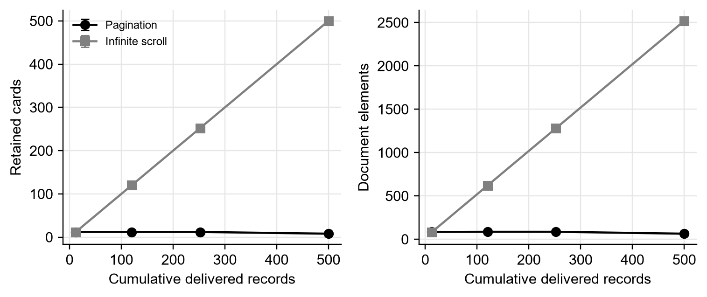
Figure 1. Retained cards and document elements at the declared content depths
N2 Evidence bundle / supplementary/analysis/all_batches.csv
Both conditions receive the same total records, but their retained content follows different paths. Pagination replaces earlier cards and finishes with the last eight records, whereas infinite scroll retains all 500. The document-element count makes the retained-content mechanism visible without using public website labels as a substitute for the local application.
Live JavaScript heap
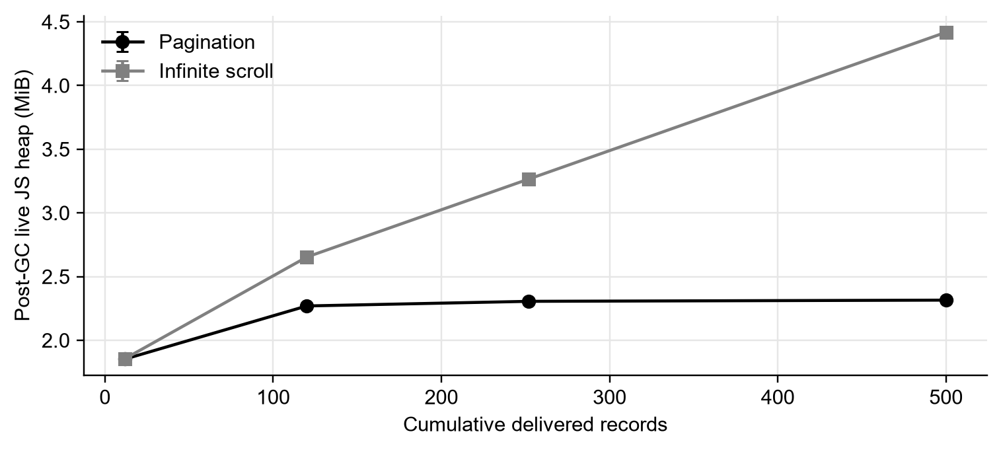
Figure 2. Post-GC live JavaScript heap by delivered-record checkpoint
N1 Evidence bundle / supplementary/analysis/all_runs.csv
N2 Evidence bundle / supplementary/analysis/all_batches.csv
N7 Evidence bundle / supplementary/analysis/summary.csv
At the final checkpoint the mean is 2.315 MiB for pagination and 4.418 MiB for infinite scroll. The error bars show SD between the twenty runs in each condition. This is a measurement of live JavaScript heap after GC; it does not include the entire browser process or directly measure user-visible delay.
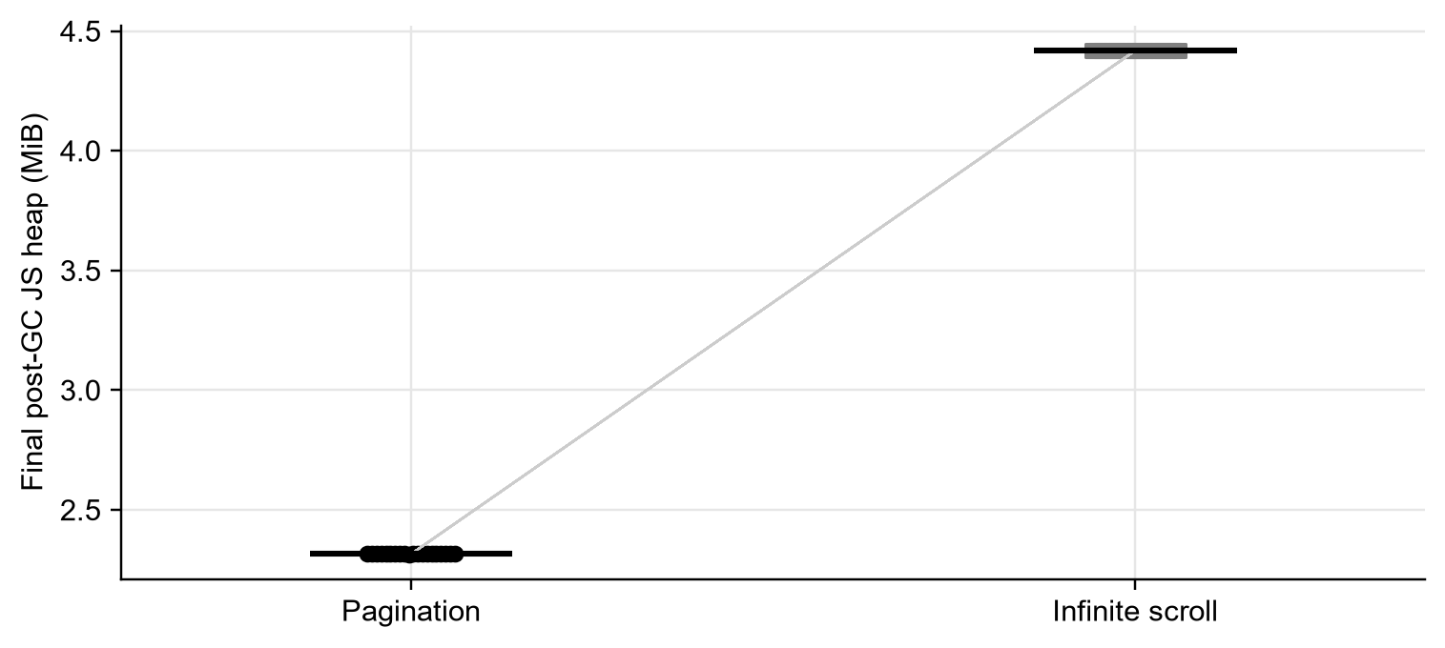
Figure 3. All twenty final-heap pairs
N1 Evidence bundle / supplementary/analysis/all_runs.csv
N3 Evidence bundle / supplementary/analysis/paired_contrasts.csv
Each line joins the two runs with the same delay seed. The mean paired difference is 2.103 MiB, while the change after removing the first pair is 2.103 MiB. The paired presentation shows whether the aggregate result depends on one run rather than hiding that question behind a single mean.
Post-GC heap varies very little because each run builds the same objects from a fixed input and then removes unreachable allocations. Several plotted markers therefore overlap, and the heap table retains additional decimal places to show its non-zero spread. DOM counts are deterministic, whereas the non-zero variation in task and loading times shows why a stable count should not be mistaken for a broken timing instrument.
Main-thread work
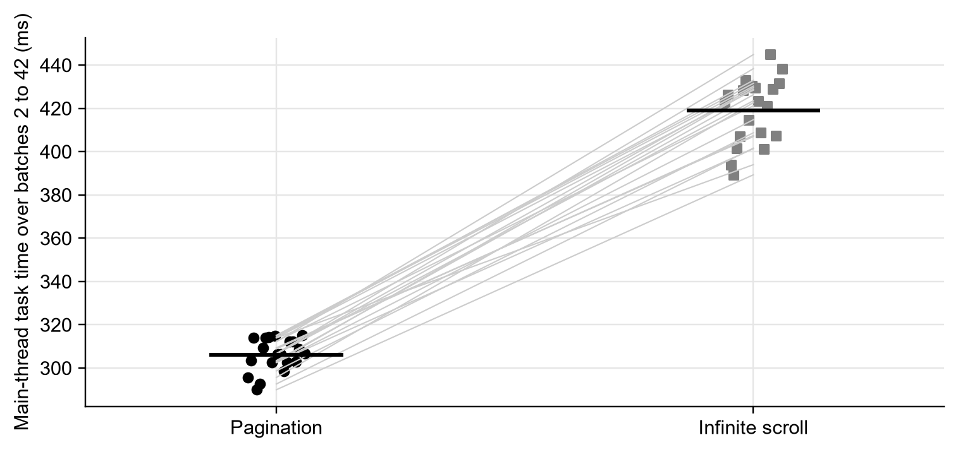
Figure 4. Main-thread task time during later browsing
N1 Evidence bundle / supplementary/analysis/all_runs.csv
N2 Evidence bundle / supplementary/analysis/all_batches.csv
N3 Evidence bundle / supplementary/analysis/paired_contrasts.csv
The mean task-time difference is 112.965 ms over batches 2 to 42. This combines browser main-thread activity observed by CDP, including application work, and is not a CPU-utilization percentage or pure rendering duration. The completion harness also performs work, so the result is best interpreted as a difference in this measured browsing procedure.
As a secondary rendering-component analysis, the recorded LayoutDuration and RecalcStyleDuration counters give 31.947 ms of style and layout work for pagination and 42.161 ms for infinite scroll. This value is the sum of the final-minus-initial differences in both counters, multiplied by 1,000 to convert seconds to milliseconds. It excludes painting and is not presented as a complete rendering-time measurement or a predeclared primary outcome.
Batch-ready delay
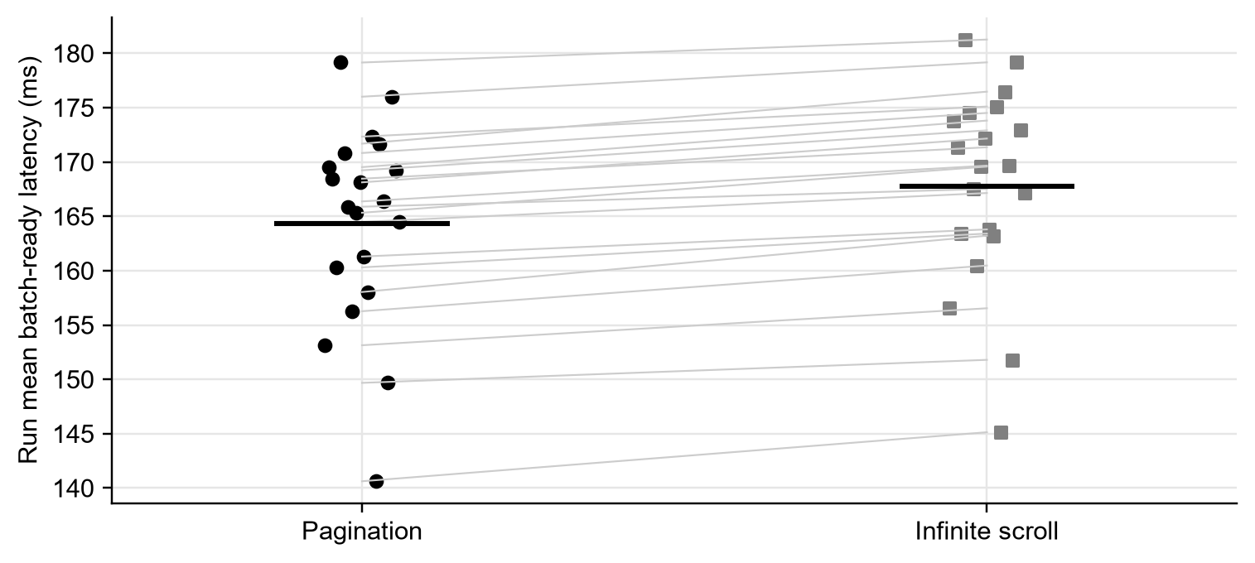
Figure 5. Mean batch-ready delay in every supplementary run
N1 Evidence bundle / supplementary/analysis/all_runs.csv
N3 Evidence bundle / supplementary/analysis/paired_contrasts.csv
The run means are 164.3 ms and 167.8 ms. Equal seeded API delays help prevent a different server-delay sequence from becoming the explanation for the contrast. The remaining difference includes interface updates and animation-frame completion and should not be confused with raw API latency.
The batch-ready difference of 3.413 ms exceeds the SD of the paired differences, 0.962 ms. It is smaller than the SD between unpaired run means because different pairs use different artificial-delay seeds. Pairing isolates a small, repeatable local contrast, but no prior practical-importance threshold was declared for this metric, so it is not described as a large user-visible improvement.
Initial paint
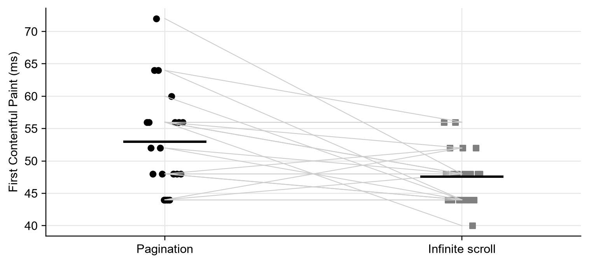
Figure 6. Initial FCP kept separate from prolonged browsing
N1 Evidence bundle / supplementary/analysis/all_runs.csv
N3 Evidence bundle / supplementary/analysis/paired_contrasts.csv
The FCP contrast is -5.4 ms, with its full run variation visible. FCP can be triggered by the shared page header before the data cards finish loading, so it is not a direct measurement of the first batch alone. This explains why the ER2 wording is stronger than the instrument supports.
Table 9. Block D requirement completion
Output | Content | Where it appears in your paper
Run table | All 40 runs; 20 repetitions per condition; each run receives 500 records. Means, SD and paired bootstrap model are defined. | Table 8; Appendix A; N1–N3; Methodology
Baseline | Pagination under matched input, viewport and pair-specific delay seed. | Methodology; Task 6
Error analysis | 0 main HTTP errors; 0 browser exceptions; historical recording errors retained separately. | Task 6; Table 10; N1, N2
Split statement | No training/test split: no model is trained. Pair is the resampling unit; website is the contextual observational unit. | Task 5; Methodology
Inspected failures | Invalid backend value; CLS transcription error; wrong Google result page. | Table 10
Resource cost | Live JS heap, task time and delay; declared hardware, software and input size. CPU utilization remains unmeasured. | Methodology; Figures 2–5; N4
Output examples | Actual interface captures, all-run values and measured plots. | Figures 1–9; Appendix A; Appendix C
N1 Evidence bundle / supplementary/analysis/all_runs.csv
N2 Evidence bundle / supplementary/analysis/all_batches.csv
N4 Evidence bundle / supplementary/measurements/environment.json
N5 Evidence bundle / supplementary/protocol.txt
The supplementary collection supplies the run-level outputs and environment information missing from the original export. The CPU-utilization and pure-rendering claims remain outside the measurements. They are not checked as complete merely because related task-time data are available.
Table 10. Three inspected historical failure cases
Case | Evidence and cause | How it affects the result
Invalid backend number | Pagination 019 HTTP p95 contains two decimal prefixes. [B1], line 92. | One value is excluded; it is not repaired by guessing.
Incorrect CLS transcription | GitHub mobile is 0.29 in the screenshot but 0.27 in CSV. [S1], page 8. | Only the processed copy changes; the raw CSV stays intact.
Wrong result page | Google mobile result URL contains /sorry/index. [S1], page 6. | Google is excluded from the primary contextual comparison, not from the local experiment.
B1 Original backend records | F1 Original frontend records | S1 Original screenshots with page numbers cited in text
All three cases concern the trustworthiness of a recorded value or its measurement object. None is evidence that one loading strategy is inherently better. The supplementary results are therefore based on directly logged local trials rather than on these problematic records.
Table 11. Block D submission checklist
Submission checkbox, choose only if it is TRUE for your research and is shown in the report
[x] Number of repetitions is stated and all runs are reported, not only the best.
[x] Baseline is defined.
[x] Split level is named; a training/test split is not applicable.
[x] At least 3 failure cases are described.
[x] Hardware, software versions and input size are stated.
[x] Every figure, graph and table in this segment has a caption and at least 2–3 sentences of interpretation.
Each selected item refers to an output already shown in the report. The checklist records completion of those outputs; it does not confirm the unmeasured CPU-utilization claim.

Task 7. Additional Interpretation

Contrast
The main contrast is the retained-content cost after viewing the same 500 records. The final document retains eight versus 500 cards, and the live-heap difference is 2.103 MiB. This contrast is a property of the replacing and appending implementations used here. It does not describe a virtualized infinite list that removes off-screen elements.

Non-finding
The non-finding is the original claim that initial paint and prolonged scrolling can be evaluated as one growing LCP measure. The local experiment records initial paint and later resource use separately. That separation makes the result easier to defend because the observed DOM and heap growth are not used to invent an unmeasured LCP degradation threshold.

Alternative explanation
Two alternative explanations need attention. Random API delay could dominate a loading-time comparison; using the same seed within a pair reduces that explanation. Run order and browser initialization could also affect the results; alternating order, excluding planned warm-up contexts and checking the first-pair sensitivity reduce that concern. These controls do not eliminate all background activity or all harness overhead, so small timing differences still require caution.

Scope
The findings apply to a single automated client, the declared local stack, the fixed viewport and the 500-record archive. They do not establish throughput under concurrent traffic, performance above 5,000 rendered nodes, production-database cost or preferences of human users. The application generates records in memory, so it cannot reproduce database-query results from the pagination literature.

Surprise
An unexpected result from checking the old evidence was that its frontend values came from field-data panels. Their mobile and desktop profiles refer to different real-user populations and cannot be treated as repeat runs of the local application. This makes them useful context, but weaker evidence for the specific replacing-versus-appending question.

Answer
Answer to the RQ: in this implementation, retaining all batches increases final live JS heap by 2.103 MiB and later browsing task time by 112.965 ms on average, while the paired mean batch-ready increase is 3.413 ms (Figures 1 to 5).

Task 8. Comparison with literature
What the technical results can be compared with

Original A2 sources
Table 12. Original A2 sources and their present evidence status
Source (author, year) | Its findings | What is your result | Relation | Why
van Riet et al. (2023) | Industrial web-performance interventions. | Resource and loading outcomes are reported separately. | Supports | Method-level comparison; not a replication of industrial interventions.
Orlivskyi et al. (2021) | Not reverified from full text. | No database pagination intervention. | Not comparable | Excluded candidate; older than the current core window.
Martha (2023 manuscript; posted 2025) | Not reverified from full text. | No engagement or preference measure. | Not comparable | Excluded SSRN candidate; peer review and full text were not verified.
Sudda (2024) | Full-text findings not reverified. | No caching intervention. | Not comparable | Excluded master’s report; accessible record alone is insufficient.
Clark (2025) | Not reverified from full text. | No combined optimization model tested. | Not comparable | Excluded SSRN candidate; no verified full-text evidence used.
Gavrila et al. (2022) | Database query/pagination execution cost. | Local API slices an array; browser heap measured. | Not comparable | Different system layer and dependent variable.
Herlihy (2022) | Abstract only; findings not reused. | No participant reading-speed result. | Not comparable | Excluded dissertation candidate; full text not retrieved.
Jain (2022) | Lazy loading and code splitting address resource delivery. | Later content retention is measured separately. | Not comparable | Insufficient benchmark detail for this comparison; code splitting not tested.
The eight retained A2 candidates are all accounted for. Excluded candidates are shown as screening history, not cited as verified findings; Appendix E records the access and selection decisions.

Updated verified studies
Table 13. Comparison with seven verified studies
Source (author, year) | Its findings | What is your result | Relation | Why
van Riet et al. (2023) | Industrial web-performance interventions. | Heap and loading delay are separate outcomes. | Supports | Supports separating outcomes; different interventions prevent direct numerical replication.
Gavrila et al. (2022) | Database-pagination execution cost. | The API slices an in-memory array. | Not comparable | Not comparable: our backend slices an in-memory array; DOM/heap does not test SQL cost.
Alnuhait et al. (2024) | Responsiveness, throughput and scalability tests. | Single-client resource cost was measured. | Extends | Method context: our single-client resource result cannot establish concurrent throughput.
Demir et al. (2022) | Reproducibility of web measurements. | Raw runs, scripts and environment are preserved. | Supports | Method agreement: raw records, scripts and conditions are preserved; old page snapshots are still missing.
Demir et al. (2023) | Sensitivity to experimental setup. | Findings are limited to the declared setup. | Supports | Scope agreement: results are bounded by the documented host and configuration.
Lipiński and Pańczyk (2023) | Controlled framework/application cases. | The same application and content are used. | Supports | Supports comparable content and metric-specific conclusions; framework is not varied here.
Joshi, Casiez and Vogel (2025) | Smartphone reading comprehension, duration and workload. | No human reading outcome was collected. | Not comparable | Not comparable to heap: their null results neither confirm nor refute our resource contrast.
The comparison identifies the measured outcome before claiming agreement or disagreement. Human reading outcomes, database execution and browser heap answer different questions. The original A2 sources that could not be retained are accounted for individually in Appendix E, rather than silently omitted or cited from abstracts.
Verified disagreement and its limits
Table 14. Disagreements distinguished from non-comparable results
Comparison type | First finding or position | Second finding or position | Interpretation and boundary
Empirical discrepancy: navigation moderation | Salmerón et al. (2024), author pp. 51–52: no detected navigation moderator; five scrolling effects. | Clinton-Lisell and Litzinger (2026), §§5.2–5.3: paper advantage for computers/tablets with scrolling; no reliable paper/device differences without scrolling. | Different study coverage and synthesis methods; significance patterns alone do not prove incompatible effect sizes. Smartphone/paper is also non-significant in the scrolling subset.
Interpretive disagreement: recommending paging | Haverkamp et al. (2023) recommend considering paging, although integrated comprehension p = .066 (PDF p. 13). | Joshi, Casiez and Vogel (2025), §3.6: no significant reading-outcome advantage on phones. | Informational text/student and short-story/phone tasks differ. This is a qualified disagreement in advice, not opposing significant effects.
Boundary check: universal scrolling penalty | The 2026 synthesis links scrolling with some paper/screen comprehension differences. | Krenca, Taylor and Deacon (2024), Results: clicking and scrolling alone had similar comprehension; poorer hyperlink conditions are separate. | Paper-versus-screen and click-versus-scroll are different contrasts. This is not a direct contradiction, and a null finding is not proof of equivalence.
The first row records an empirical discrepancy between syntheses; it does not prove that their effect estimates are statistically incompatible. The second concerns qualified recommendations, and the third is explicitly not a contradiction. None of these reading studies directly tests the JavaScript-heap result of the present application.
This distinction changes the practical inference. A larger retained DOM can explain a larger local resource footprint without proving that scrolling harms comprehension. Conversely, a null reading result cannot establish that two implementations consume equal memory. The present experiment addresses the technical part of this gap and leaves human-task outcomes for a separate study.
Historical public-site context
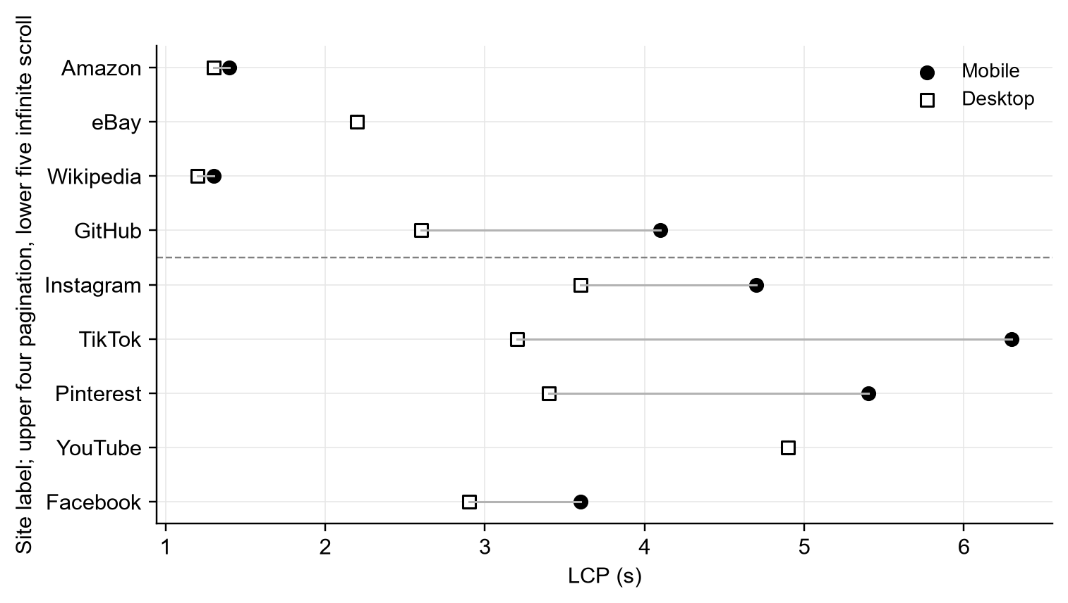
Figure 7. Original public-site LCP values shown only as context
F1 Original frontend records | S1 Original screenshots with page numbers cited in text
The selected infinite-scroll-labelled websites tend to have higher stored LCP, but the groups contain different sites, content and field populations. The plot cannot establish the effect of changing the loading strategy inside one website. It is therefore kept separate from the controlled local comparison.

Task 9. Validity and Limitations
Table 15. Limits that change what can be concluded
Limitation | Name exactly what in your study
Internal validity | DOM retention changes with strategy, and the harness must observe DOM completion.  Consequence: The memory result fits this implementation; task timing includes some instrument work.
Construct validity | Post-GC JS heap excludes other browser memory; TaskDuration is not CPU utilization.  Consequence: The report cannot claim complete memory cost or stable CPU utilization.
Reliability | 20 pairs are repeated on one host, with normal background activity.  Consequence: Intervals describe run variation here, not all devices or production conditions.
External validity | 500 text records, one viewport and one automated client.  Consequence: No conclusion about large images, virtualized lists, high concurrency or larger archives.
Initial paint | The shared header can determine FCP and initial LCP.  Consequence: These metrics do not isolate first-batch rendering or later DOM-growth effects.
Historical reproducibility | Public-site panels are saved, but page snapshots, HAR and original environment logs are missing.  Consequence: The old collection cannot be recreated exactly; it is not treated as a controlled trial.
S1 Original screenshots with page numbers cited in text
N4 Evidence bundle / supplementary/measurements/environment.json
N5 Evidence bundle / supplementary/protocol.txt
These limitations define the boundaries of the answer. The supplementary experiment supports a local comparison of retention cost and loading delay, while the broader original claim about web application performance remains dependent on workload, implementation and equipment.

Segment 4. Conclusion
Answer and contribution
For the tested React and Node.js application, replacing earlier batches and retaining them lead to different resource footprints after the same content has been viewed. Pagination finishes with eight cards and infinite scroll with 500. Mean final post-GC JavaScript heap is 2.315 MiB and 4.418 MiB respectively, a paired difference of 2.103 MiB. This answers the retained-content part of the research question for the declared implementation.
Loading delay is a separate outcome. Mean batch-ready time is 164.3 ms for pagination and 167.8 ms for infinite scroll. The difference must be considered together with its run variation, rather than inferred from the amount of retained memory. The browser-task measurement also describes work during the tested procedure; it does not establish CPU utilization or isolate rendering from every other task.
The useful contribution is a direct comparison in which the application, input and delivered record count are held comparable. The results distinguish the cost of keeping previously viewed content from the cost of requesting the next batch.
This distinction is important for developers because a loading method can have a larger retained footprint without being uniformly worse on every initial-load or latency metric. It also explains why observations from unrelated public websites are insufficient to identify the effect of one navigation rule.
Expectations and next study
The original expectations are only partly confirmed. The initial-memory direction in ER1 matches the observations, but CPU-utilization stability was not measured. The FCP direction in ER2 also matches, but initial paint does not provide the proposed LCP growth measure. Keeping the unsupported parts visible is more accurate than changing either expectation after seeing the data. The strongest resource result concerns later live-heap retention, not a universal performance ranking.
The study does not show how the same approaches perform with virtualized lists, large media resources, concurrent users or a production database. It also does not establish user preference, reading performance or a threshold above the tested content volume.
The next experiment should compare the same application with and without list virtualization, preserve identical browsing tasks, and measure frame timing alongside live heap at larger content depths. That would test whether removing off-screen elements reduces the retained-content cost without changing the intended browsing interaction.
Table 16. Conclusion submission checklist
Submission checkbox, choose only if it is TRUE for your research and is shown in the report
[x] Answer to RQ is stated in 1–2 sentences; methodology is not re-described.
[x] Every number in Conclusion already appeared in Segment 3.
[x] The study’s limits are explicit and future work names a specific direction.
The checks refer to the conclusion above. No new numerical result or new source is introduced by this checklist.

References
Alnuhait, H., Alzyadat, W., Althunibat, A., Kahtan, H., Zaqaibeh, B. and Al-Khawaja, H.A. (2024) Web application performance assessment: a study of responsiveness, throughput, and scalability. International Journal of Advanced and Applied Sciences, 11(9), pp. 214-226. doi:10.21833/ijaas.2024.09.023.
Clinton-Lisell, V. and Litzinger, C. (2026) Decoding digital reading: a network meta-analysis of comprehension across devices. Education and Information Technologies, 31, pp. 1611–1643. doi:10.1007/s10639-025-13843-8.
Demir, N., Große-Kampmann, M., Urban, T., Wressnegger, C., Holz, T. and Pohlmann, N. (2022) Reproducibility and replicability of web measurement studies. In Proceedings of the ACM Web Conference 2022, pp. 533-544. doi:10.1145/3485447.3512214.
Demir, N., Hörnemann, J., Große-Kampmann, M., Urban, T., Pohlmann, N., Holz, T. and Wressnegger, C. (2023) On the similarity of web measurements under different experimental setups. In Proceedings of the 2023 ACM Internet Measurement Conference, pp. 356-369. doi:10.1145/3618257.3624795.
Gavrila, C., Pop, P.G., Tamas, I. and Striletchi, C. (2022) Study and experiments on data pagination and calculation of simple and matrix totals. In 2022 IEEE International Conference on e-Business Engineering, pp. 252-257. doi:10.1109/ICEBE55470.2022.00051.
Google (n.d.a) About PageSpeed Insights. Available at the linked official documentation (Accessed: 29 October 2026).
Google (n.d.b) Cumulative Layout Shift. Available at web.dev (Accessed: 29 October 2026).
Google (n.d.c) Interaction to Next Paint. Available at web.dev (Accessed: 29 October 2026).
Haverkamp, Y.E., Bråten, I., Latini, N. and Salmerón, L. (2023) Is it the size, the movement, or both? Investigating effects of screen size and text movement on processing, understanding, and motivation when students read informational text. Reading and Writing, 36, pp. 1589–1608. doi:10.1007/s11145-022-10328-9.
Joshi, N., Casiez, G. and Vogel, D. (2025) Is pagination better than scrolling when reading on a phone? In Extended Abstracts of the CHI Conference on Human Factors in Computing Systems (CHI EA ’25), pp. 1–6. doi:10.1145/3706599.3720178.
Krenca, K., Taylor, E. and Deacon, S.H. (2024) Scrolling and hyperlinks: the effects of two prevalent digital features on children’s digital reading comprehension. Journal of Research in Reading, 47(3), pp. 269–291. doi:10.1111/1467-9817.12468.
Lipiński, A. and Pańczyk, B. (2023) Performance optimization of web applications using Qwik. Journal of Computer Sciences Institute, 28, pp. 197-203. doi:10.35784/jcsi.3672.
Prometheus (n.d.) Query functions: histogram_quantile. Available at the linked official documentation (Accessed: 29 October 2026).
Salmerón, L., Altamura, L., Delgado, P., Karagiorgi, A. and Vargas, C. (2024) Reading comprehension on handheld devices versus on paper: a narrative review and meta-analysis of the medium effect and its moderators. Journal of Educational Psychology, 116(2), pp. 153–172. doi:10.1037/edu0000830.
van Riet, J., Malavolta, I. and Ghaleb, T.A. (2023) Optimize along the way: an industrial case study on web performance. Journal of Systems and Software, 198, article 111593. doi:10.1016/j.jss.2022.111593.
Walton, P. and Pollard, B. (2025) Largest Contentful Paint. Updated 4 September 2025. Available at web.dev (Accessed: 29 October 2026).

Appendix A All Supplementary Runs
All forty measured runs are listed below. The two pilot runs and warm-up contexts are separate files, and no main run was removed. Each row links to its pair through the pair number in the run ID.
Table 17. All pagination runs
Run ID | Final heap MiB | Task time ms | Mean ready ms | FCP ms | API n
R01_pagination | 2.315517 | 295.670 | 153.137 | 56.0 | 42
R02_pagination | 2.315529 | 303.457 | 169.527 | 56.0 | 42
R03_pagination | 2.315575 | 313.949 | 168.463 | 52.0 | 42
R04_pagination | 2.315258 | 289.983 | 160.302 | 48.0 | 42
R05_pagination | 2.315269 | 292.646 | 179.154 | 64.0 | 42
R06_pagination | 2.315521 | 309.358 | 170.827 | 72.0 | 42
R07_pagination | 2.315269 | 313.951 | 165.883 | 64.0 | 42
R08_pagination | 2.315201 | 314.256 | 156.268 | 52.0 | 42
R09_pagination | 2.315247 | 302.529 | 165.329 | 48.0 | 42
R10_pagination | 2.314960 | 314.926 | 168.127 | 44.0 | 42
R11_pagination | 2.315224 | 306.528 | 161.298 | 44.0 | 42
R12_pagination | 2.315247 | 306.523 | 158.037 | 44.0 | 42
R13_pagination | 2.315247 | 298.678 | 172.334 | 44.0 | 42
R14_pagination | 2.315269 | 302.671 | 140.622 | 60.0 | 42
R15_pagination | 2.315208 | 312.377 | 171.685 | 48.0 | 42
R16_pagination | 2.315578 | 312.246 | 166.373 | 56.0 | 42
R17_pagination | 2.315182 | 302.914 | 149.676 | 48.0 | 42
R18_pagination | 2.315247 | 308.898 | 176.007 | 56.0 | 42
R19_pagination | 2.315510 | 315.129 | 169.234 | 48.0 | 42
R20_pagination | 2.315189 | 306.715 | 164.483 | 56.0 | 42
N1 Evidence bundle / supplementary/analysis/all_runs.csv
N2 Evidence bundle / supplementary/analysis/all_batches.csv
The table includes each valid run and preserves the variation between them. The timing columns describe different outcomes and must not be combined into one performance score.
Table 18. All infinite runs
Run ID | Final heap MiB | Task time ms | Mean ready ms | FCP ms | API n
R01_infinite | 4.418324 | 422.613 | 156.539 | 56.0 | 42
R02_infinite | 4.418297 | 426.312 | 173.810 | 48.0 | 42
R03_infinite | 4.418301 | 393.993 | 171.354 | 44.0 | 42
R04_infinite | 4.418312 | 389.311 | 163.415 | 52.0 | 42
R05_infinite | 4.418297 | 401.621 | 181.266 | 44.0 | 42
R06_infinite | 4.418308 | 406.982 | 174.512 | 48.0 | 42
R07_infinite | 4.418278 | 428.408 | 167.522 | 56.0 | 42
R08_infinite | 4.418320 | 432.965 | 160.471 | 48.0 | 42
R09_infinite | 4.418301 | 414.763 | 169.576 | 44.0 | 42
R10_infinite | 4.418308 | 430.272 | 172.156 | 44.0 | 42
R11_infinite | 4.418278 | 429.595 | 163.798 | 52.0 | 42
R12_infinite | 4.418278 | 423.527 | 163.217 | 48.0 | 42
R13_infinite | 4.418297 | 408.719 | 175.102 | 44.0 | 42
R14_infinite | 4.418324 | 401.378 | 145.132 | 44.0 | 42
R15_infinite | 4.418297 | 421.183 | 176.471 | 48.0 | 42
R16_infinite | 4.418301 | 444.859 | 169.666 | 40.0 | 42
R17_infinite | 4.418312 | 428.814 | 151.793 | 44.0 | 42
R18_infinite | 4.418297 | 407.461 | 179.168 | 52.0 | 42
R19_infinite | 4.418301 | 431.566 | 172.910 | 48.0 | 42
R20_infinite | 4.418301 | 438.357 | 167.144 | 48.0 | 42
N1 Evidence bundle / supplementary/analysis/all_runs.csv
N2 Evidence bundle / supplementary/analysis/all_batches.csv
The table includes each valid run and preserves the variation between them. The timing columns describe different outcomes and must not be combined into one performance score.

Appendix B Other A3 Expectations Unchanged
The main ER1 and ER2 sentences in Task 4 are unchanged. The additional scenario and method declarations below also retain their original wording; verdicts are added in a separate column.
Expectations Fixed Date: 23.10.2026
Table 19. Original scenarios with verdicts
Original category | Original scenario unchanged | Verdict
Scenarios for Bad Outcomes | Prometheus monitoring fails to capture metrics due to socket timeout under high concurrency. | Not confirmed: no high-concurrency experiment was run.
Scenarios for Bad Outcomes | PageSpeed Insights scores show high variance due to background network fluctuations. | Not confirmed: the original field panels are not repeat runs of an identical page.
Scenarios for Medium Outcomes | 3. Pagination and infinite scroll show negligible difference in server CPU utilization but distinct memory divergence. | Not confirmed as written: CPU utilization was not measured; live heap is reported separately.
Scenarios for Medium Outcomes | 4. Frontend rendering metrics vary only under extreme dataset sizes (>5,000 rendered nodes). | Not confirmed: the supplementary archive contains 500 records, not a measured test above 5,000 nodes.
Scenarios for Good Outcomes | 5. Clear, statistically significant performance thresholds identified where infinite scroll degrades browser rendering efficiency. | Not confirmed: no browser-rendering degradation threshold is established.
Scenarios for Good Outcomes | 6. Backend throughput metrics distinctly favor batched pagination queries under high concurrent load. | Not confirmed: no controlled concurrent-throughput experiment was conducted.
The original expectations remain available for checking against A3. Measurements that were not made are not described as confirmed simply because a related metric was collected.
Table 20. Original method declarations with verdicts
Method | Original declaration | Verdict
Experiment | Expected direction: Pagination is expected to deliver faster loading times and higher visual stability compared to infinite scroll.  Smallest meaningful difference: A 0.5 s difference in Largest Contentful Paint (LCP) or a 50 ms difference in Interaction to Next Paint (INP).  • Result indicating no effect: Identical LCP, INP, and CLS scores across both conditions despite increasing content volume | Not confirmed as a universal ranking; the measured outcomes are reported separately.
Technical | Expected value/range: Backend HTTP latency expected under 0.3 s per batch; frontend LCP expected under 2.5 s for pagination and under 4.5 s for infinite scroll.  • Expected ranking: Pagination will rank higher in overall performance and layout stability than infinite scroll.  • Failure modes expected: DOM bloat and layout shift (CLS spikes) during rapid continuous content appends.  • Result indicating broken process: Zero variance across test runs or completely missing metric logs. | Only the declared local resource and delay outcomes are established; DOM growth is not renamed as an LCP threshold.
Software development | Expected pass/fail: 100% pass rate across all API query endpoints (/api/items) and PageSpeed audit runs.  • Expected performance metrics: Stable backend request duration (under 0.3 s) and 0% HTTP error rate.  • Usability problem expected first: Frame drops (scroll jank) and Cumulative Layout Shift during continuous DOM node insertion. | The new sample has 1,680 successful API responses and no browser exceptions. This does not establish success for every historical PageSpeed audit or a usability outcome.
The original expectations remain available for checking against A3. Measurements that were not made are not described as confirmed simply because a related metric was collected.

Appendix C Observed Interface States
The following two demonstration runs were collected separately after the measured sample to capture the final navigation state clearly. They are not added to the forty-run analysis.

Figure 8. Pagination final state in separate demonstration D01
N8 Evidence bundle / supplementary/demonstration/D01_pagination.json and D01_infinite.json
The final page retains the last eight cards of the 500-record archive. The demonstration log confirms that all 42 fetches completed, and the screenshot shows the final navigation state.
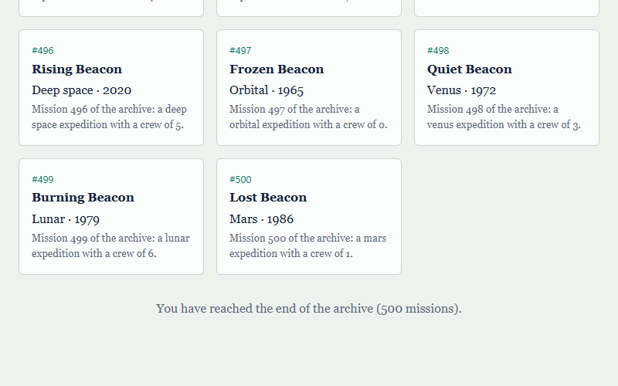
Figure 9. Infinite scroll final state in separate demonstration D01
N8 Evidence bundle / supplementary/demonstration/D01_pagination.json and D01_infinite.json
The infinite-scroll demonstration has received the same 500 records and retains all 500 cards. Its capture shows the end of the archive and is paired with the raw count in the demonstration log; it is not presented as a screenshot of every intermediate action.

Appendix D Evidence Index
Original team files are linked below at their fixed repository revision. Supplementary raw logs, prepared tables, figures, protocol, environment record, scripts and dependency lockfiles are in the supplementary directory of the evidence bundle. The run ID and page number identify each measurement without relying on a selected screenshot.
B1 Original backend records
F1 Original frontend records
S1 Original screenshots with page numbers cited in text
C1 Backend source
C2 Shared frontend fetch function
C3 Pagination runner
C4 Infinite scroll runner
C5 Pagination component
C6 Infinite scroll component
C7 Tracker
C8 Declared software dependencies
C9 Backend dependency ranges
N1 Evidence bundle / supplementary/analysis/all_runs.csv
N2 Evidence bundle / supplementary/analysis/all_batches.csv
N3 Evidence bundle / supplementary/analysis/paired_contrasts.csv
N4 Evidence bundle / supplementary/measurements/environment.json
N5 Evidence bundle / supplementary/protocol.txt
N6 Evidence bundle / supplementary/measurements/R01_pagination.json and R01_infinite.json
N7 Evidence bundle / supplementary/analysis/summary.csv
N8 Evidence bundle / supplementary/demonstration/D01_pagination.json and D01_infinite.json
To reproduce the supplementary collection, install the preserved frontend/backend dependencies with their lockfiles, build the frontend, run the instrumented backend and gateway, and execute run_portable.cjs. To reproduce only the calculations, run analyse_supplement.py against the saved JSON files. Repeating measurements will produce different timing values; the saved raw values reproduce the reported tables and figures.

Appendix E Literature Search and Selection Audit
This targeted update was conducted on 29 October 2026, rather than presented as an exhaustive systematic review. Searches combined pagination, scrolling, reading comprehension, smartphone, full text and meta-analysis; exact titles and DOIs were used to check the A2 candidates. The evidence-bundle search log records the query families and access versions.
Inclusion and exclusion criteria
Include: a 2022–2026 journal or conference publication with identifiable authors, peer review, accessible full methods/results and relevance to navigation outcomes, technical benchmarking or reproducibility. Author manuscripts are accepted with their version identified.
Exclude from the evidence base: an abstract-only record; failed full-text retrieval; unverified peer-review status; insufficiently traceable benchmark methods for the intended comparison; or publication outside the stated window. Official metric documentation is not counted as peer-reviewed research.
The active research set contains eleven journal/conference publications. The five official documentation references support metric definitions only. The reference list contains direct full-text links, including the author manuscript for Salmerón et al. (2024); a publication record alone is not treated as full-text access.
Table 21. Selection decisions for the original A2 candidates
A2 candidate | Decision | Specific reason
van Riet et al. (2023) | Retain | Full text checked; industrial context, not a direct replication.
Gavrila et al. (2022) | Retain | Full proceedings text checked; database outcome differs from browser outcome.
Orlivskyi et al. (2021) | Exclude from evidence | Full text not retrieved; outside the core 2022–2026 publication window.
Martha (manuscript dated 2023; posted 2025) | Exclude from evidence | SSRN record only; full-text retrieval failed and peer-review status unverified.
Sudda (2024) | Exclude from evidence | Master’s report; accessible record but full-text retrieval failed. Not counted as peer-reviewed.
Clark (2025) | Exclude from evidence | SSRN record only; full-text retrieval failed and peer-review status unverified.
Herlihy (2022) | Exclude from evidence | Dissertation record/abstract available, full text not retrieved. Abstract results are not reused.
Jain (2022) | Exclude from evidence | Full text available, but benchmark repetition/environment details are insufficient for this comparison. DOI attribution in A2 was unreliable.
Alnuhait et al. (2024), rejected in A2 | Reinstate for method context | Full text checked; relevant to performance-test design, not proof about scrolling.
Sharma and Murano (2020), listed as 2021 in A2 | Exclude from current core | Publication-year correction; outside 2022–2026. Earlier usability work is not a current technical benchmark.
Every source in the eight-row A2 retained matrix is represented, along with the previously rejected method source and the misdated usability paper. Excluded entries are screening records, not supporting citations, and are not counted in the active reference list. This preserves the comparison history without assigning findings to unread full texts.
Table 22. Full-text verification register
Active publication | Access version | Locator for verification
Alnuhait et al. (2024) | Publisher PDF | Methods and experimental evaluation
Clinton-Lisell and Litzinger (2026) | Publisher open-access PDF | PDF pp. 17–20, §§5.2–5.3, Table 4 and §6.2; phone/paper contrast is not significant
Demir et al. (2022) | Author/institutional PDF | Research design, findings and recommendations
Demir et al. (2023) | Author PDF | Experimental setup and results
Gavrila et al. (2022) | Conference proceedings PDF | Experiment/results section
Haverkamp et al. (2023) | Publisher open-access PDF | PDF p. 13, integrated understanding: p = .066; discussion and conclusion
Joshi, Casiez and Vogel (2025) | Author PDF | PDF p. 4, §§3.6.1–3.6.3; Table 2; discussion
Krenca, Taylor and Deacon (2024) | Publisher open-access full HTML | Results and discussion; distinguish the hyperlink conditions
Lipiński and Pańczyk (2023) | Publisher PDF | PDF pp. 4–6, results and §6; Table 6 prevents a universal-winner claim
Salmerón et al. (2024) | Full author manuscript (pre-print label) | Author PDF pp. 51–52, Text factors; five vertical-scrolling effects
van Riet, Malavolta and Ghaleb (2023) | Author PDF | Study design, results and discussion
The register distinguishes publisher texts from author copies and identifies where the disputed claims can be checked. A downloadable PDF was not available for every item: the Krenca study was read as full publisher HTML. Direct links and complete metadata are also supplied in literature/verified_full_texts.csv in the evidence bundle.

